Task 16 Kubernetes
Installed kubectl
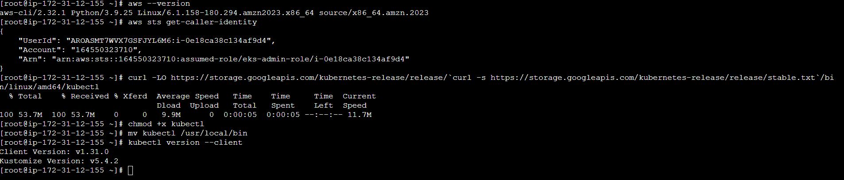

Installed eksctl

Cluster Created – 2 Nodes
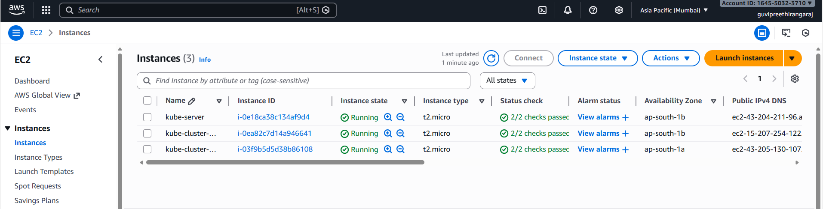

Pods created
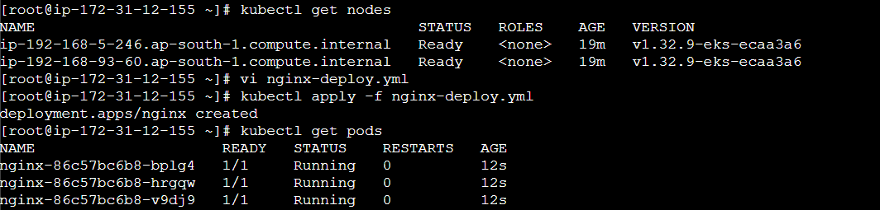

Nginx exposed outside world
